Annual CLAMBAKE
Dinner includes: One Dozen Rhode Island Little Neck Clams, ½ Seasoned Chicken, Sweet Potato, Sweet Corn, Clam Chowder, Cole Slaw, Rolls, Dessert, Beverages (including beer)
Saturday  Sept. 10, 2016  Serving 6:30 to 7:30 PM |  | 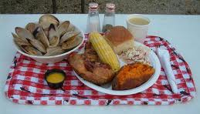
St. Mary of the Falls Community Room
(Parish Hall in Case of Rain)
26515 Bagley Road, Olmsted Falls, OH
Tickets available after all weekend Masses and during the week at the parish office.
NO TICKETS SOLD AT THE DOOR. ADVANCE ORDER ONLY.
Catered by
LOBSTER
BROTHERS!
$24.00 (13-64 Years Old)
$22.00 (65 Years Old and Over)
$3.00 (5-12 Years Old)
(Hot Dog, Chips, Side, Dessert)
$6.00 Extra Dozen Clams

